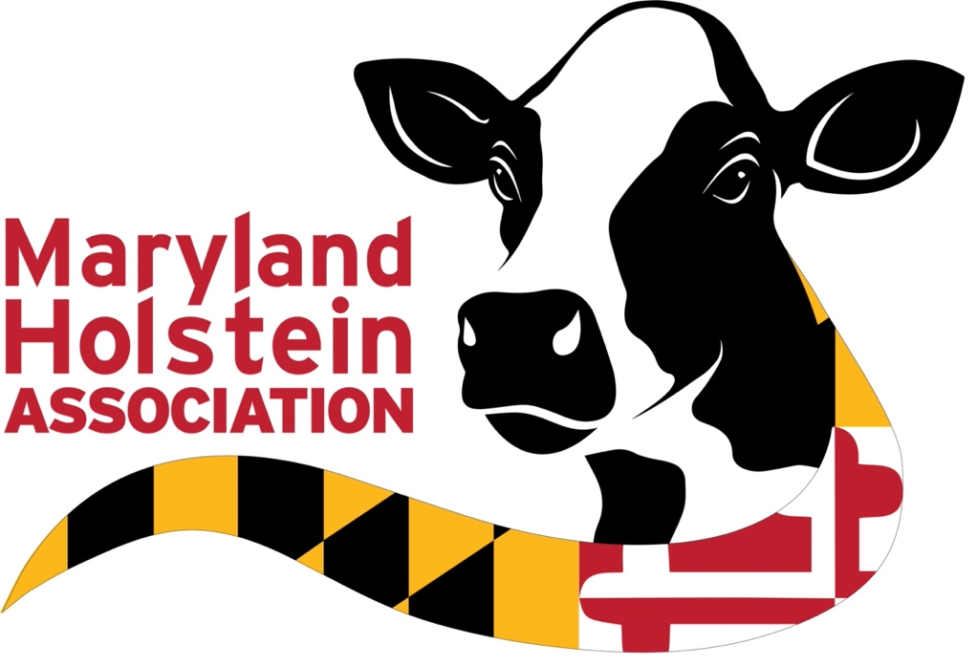

2022 Maryland Holstein Scholarship
Application

One to Four $750 Scholarships
MARYLAND HOLSTEIN SCHOLARSHIPS
Offered to Maryland 4-H and FFA youth who have had registered Holsteins as a project.
History: The Maryland Holstein Scholarship program was developed by the Maryland Holstein Association Scholarship Committee and Mylo S. Downey, Associate Director for Agricultural Development Programs at the University of Maryland. The first Maryland Holstein Scholarship was awarded in the fall of 1973. One $300 scholarship was awarded to a student attending the University of Maryland who was approved by the scholarship committee, the Dairy Department, and the Common Agricultural School of the University of Maryland. The basis of the original award was the promise of leadership, satisfactory scholastic rank and financial need. Applicants must also have been enrolled in the 4-H or FFA program working with Holsteins. Funding for the first scholarship was obtained through a letter accompanying the yearly dues statement asking for a minimum donation of $1.00 from each state member.
QUALIFICATIONS:
- Students must be attending a two-year or four-year degree-granting institution in a College of Agriculture (i.e., University of Maryland, College Park; University of Maryland Institute of Applied Agriculture, or any out-of-state university offering an agriculture degree.) or a four year college in a non-agriculture area of study.
- NEW-Students entering a Vocational School may also apply (i.e. welding, plumbing, electrical, data entry)
- Available to both undergraduate and graduate students.
- One to four scholarships offered to Maryland 4-H/FFA youth who are currently enrolled or have been enrolled in a dairy project with Holstein cattle.
- Applicants are eligible to win a scholarship twice.

A FULL ACADEMIC TRANSCRIPT AND A WALLET SIZED, HEAD SHOT PHOTO MUST BE EMAILED OR ATTACHED.
Please TYPE

I. GENERAL INFORMATION

Last Name First Name Middle Name

Home Address

City County State and Zip Code

Telephone Number E-mail Address Date of Birth

Name of University or College Year at University or College

_______
College Major College Minor Planned Graduation Date

High School Attended Date Graduated from High School

Can we notify your local newspaper of an award? Yes No

Name of Newspaper Email Address

Family Information:
Father’s Full Name Occupation

Mother’s Full Name Occupation

Siblings (number of siblings):
Siblings (number attending college):

MARYLAND HOLSTEIN ASSOCIATION
YOUTH SCHOLARHIP
APPLICATION FORM

II. FINANCIAL INFORMATION
Do you currently work while attending school? Yes No
If yes, why?

Explain your financial need:

List total scholarships/financial aid: received for the current school year
College Expenses for current year (please complete).

1. Annual tuition:

2. Annual room and board

3. Other expenses, including books:

- Total annual expenses

- Scholarships & amounts received for the 2021/2022 school year
___________________________________________________________________

___________________________________________________________________

- Other financial need received___________________________________________

III. ORGANIZATIONS THAT YOU AND/OR YOUR FAMILY BELONGS TO: (Breed Organizations, Co-ops, Farm Bureau, Grange, etc)

IV. HIGH SCHOOL

Name of High School City, State Date of Graduation GPA
Extracurricular Activities (List Format):

School-related Honors (List Format):

V. COLLEGE ACTIVITES (List Format)

VI. 4-H/ FFA/HOLSTEIN ACTIVITIES

Name of Club or Chapter Date of enrollment
Offices held:

Briefly discuss your dairy project (animals owned, leased, etc):

Maryland Holstein Activities:

Other dairy related activities (judging, dairy bowl, demonstrations, public speaking, etc):

Honors and awards received from your dairy project activities:

Awards received on your dairy animals:

VII. FARM AND WORK EXPERIENCE
Please list your responsibilities working or interning on a dairy farm; an agriculture-related business; and /or other work experience that has helped your personal growth and leadership:

VIII. COMMUNITY AND CHURCH
Please list community and church activities that you are involved with:

IX. CAREER GOALS (If attending Vocational School

X. ESSAY QUESTION (Answer should be double spaced and no longer than one page in length)
We now have two years of COVID 19 behind us and have had many restrictions. However, what may have been a positive outcome that you have learned from the pandemic that will help you in the future to attain your goals in the agriculture industry?
Please email completed scholarship applications to:

Dee Shafer or Kelly Zepp
shafdon@aol.com zredcows@gmail.com

Scholarship Applications must be emailed no later than April 15th.

Scholarships will be awarded at the Summer Dairy Picnic as best we can determine at this time

