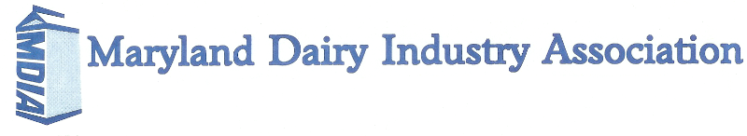

Boyd Cook Memorial Scholarships

Scholarship Awards Program

One $1000 Scholarship
Two $500 Scholarships
(Dependent upon applications)
MARYLAND DAIRY INDUSTRY ASSOCIATION
BOYD COOK MEMORIAL SCHOLARSHIPS
Offered to MDIA members and their dependents
QUALIFICATIONS:
- Must have MDIA membership for the current year or be a dependent of a member. Contact Laurie Savage for a membership form.
- Available to graduating high school seniors, undergraduate students enrolled in a 2- or 4-year college and graduate/professional school students.
- Applicants can win each award level only once.
- Scholarship will be awarded directly to the student.
- A recent photo and transcript (official or unofficial) must be attached.
- Please TYPE, limit answers to the pages allotted and use 12-point font or you will be disqualified.

PREVIOUS WINNERS:
2008 – Amy Yeiser ($250)
2009 – Tracey Forsythe ($250) and Caitlin Patrick ($250)
2010 – Claybourne Zimmerman ($500) and Samantha Garst ($500)
2011 – Rachel Manning ($500) and Carissa Doody ($500)
2012 – Carissa Doody ($1000), Jason Zimmerman ($500) and Tracey Forsythe ($500)
2013 – Clayborne Zimmerman ($1000), Nicole Hood ($500) and Audrey Ervin ($500)
2014 - Jessica Sentelle ($1000), Ryan Zimmerman ($500) and Lizzie Davis ($500)
2015 - Shelby Hahn ($1000), Julia Doody ($500) and Katelyn Allen ($500)
2016 - Julia Doody ($1000), Ian Doody ($500) and Ben Miller ($500)
2017 - Josiah Manning ($1000), Courtney Hoff ($500) and Autumn Lippy ($500)
2018 - Katelyn Allen ($1000), Todd Allen ($500) and Catherine Savage ($500)
2019 - Catherine Savage ($1000), Lindsay Smith ($500) and Cory Zimmerman ($500)
2020 - Todd Allen ($1000)
2021 - Courtney Schrader ($1,000), Jill Allen ($500), Chad Patterson ($500)
2022 - Chad Patterson ($1,000) and Shea Cencula ($500)
Please mail completed scholarship applications to:
MDIA, 23301 Mount Ephraim Road, Dickerson, MD 20842
Or submit electronically to LaurieZSavage@aol.com
Scholarship applications must be postmarked no later than February 28, 2023

MDIA BOYD COOK MEMORIAL SCHOLARSHIPS
APPLICATION FORM

I. GENERAL INFORMATION

Last Name First Name Middle Name

Home Address

City County State and Zip Code

Telephone Number E-mail Address

University or College (Name, city, state) Year at University or College

College Major College Minor Planned Graduation Date

High School Attended (Name, city, state) Date Graduated or Planned

Can we notify your local newspaper of an award? Yes No

Name of Newspaper Street Address

City County State and Zip Code

Family Information:
Father’s Full Name Occupation

Mother’s Full Name Occupation

Siblings (number attending college):

Type of Membership with MDIA: ________________________________________________________
(individual, academic/government/retired, affiliate, sustaining, student)

II. DAIRY AND AGRICULTURAL ORGANIZATIONS
Dairy/breed and other agricultural organizations to which you belong (including leadership roles):

Dairy or agriculture related activities and awards:

III. OTHER ACTIVITIES
School activities and awards:

Church and community activities:

IV. FARM AND WORK EXPERIENCE
Please list your responsibilities working on a dairy farm or in an agriculture-related business:

V. CAREER GOALS

VI. ESSAY
The Maryland dairy industry is shrinking with just over 300 dairy farms left. What are some ways industry organizations such as MDIA, Maryland Dairy Shrine and various breed organizations can band together or evolve to make the industry stronger?
(Please limit answer to space below.)

