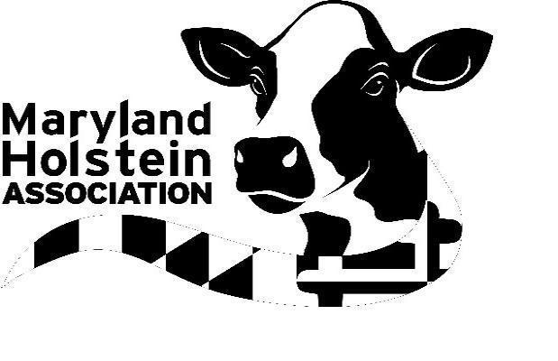MARYLAND HOLSTEIN NEWS

https://marylandholstein.com - marylandholstein@gmail.com

ANNUAL MEMBERSHIP RENEWAL

The Maryland Holstein Association is accepting dues payment with debit or credit card via our website. Go to https://marylandholstein.com/membership/ for more information and to make your dues payment online, as well as make any changes to your directory listing (only if changes are needed) and donations to the scholarship and junior trip fund. Be sure to scroll down for directory change form and donation buttons. For those who wish to continue paying by check, the membership renewal form is enclosed. Note, there may only be two members per family/farm, per membership, per address. If Maryland Holstein materials need to be sent to more than one address, there must be a membership for each address. If there are more than two people on your membership form, only the first two listed will be considered members. Membership fee is $50, plus 40 cents for each registered/identified Holstein ancestry female that has freshened. Dues should be paid by January 31. State membership allows animals to be registered at the lowest price. To be listed as a breeder on the association website directory to advertise your herd, there is a $20 fee, payable with membership. There is also space to elect this payment on the online form.

DONATIONS

The scholarship committee and junior committee are accepting donations, including major gifts. If interested in giving, write separate check to Maryland Holstein Foundation, Inc., a 501(c)(3) organization. A box on the membership form and the website designates funds for scholarships or junior trips. We appreciate your support of Holstein youth. Please note, the trip fund is in particular need of donations. We are also always looking for show sponsors.

MARYLAND HOLSTEIN GEAR

Maryland Holstein gear is available online on our clothing site: https://www.bonfire.com/store/maryland-holstein-gear/. This on-demand order site also kicks back a few dollars to help the association with each sale.

MARYLAND HOLSTEIN FUTURITY

Information and entry forms for the Maryland Holstein Futurity are included. Entries are due December 31.

UPCOMING DAIRY DATES

Visit https://ansc.umd.edu/extension/dairy-extension/dairy-youth for more information on upcoming 4-H dairy events and for 4-H dairy bowl, judging and skillathon resources. Dairy industry and 4-H upcoming dairy events are listed below.

MD Holstein Banquet - Friday, Feb. 27, 6 to 7 p.m. social time, 7 p.m. banquet, New Windsor Fire Hall
MD Dairy Shrine Banquet - Saturday, March 14, 6 p.m., Howard County Fairgrounds Annex Building (https://sites.google.com/site/mddairyshrine/home, mddairyshrine@gmail.com)
MD 4-H Dairy Bowl - Saturday, April 11 (tentative)
MD Holstein Spring Show - Saturday, April 18, Howard County Fairgrounds

MARYLAND HOLSTEIN BANQUET

The Maryland Holstein Association is hosting an awards banquet Friday, February 27, at the New Windsor Fire Hall. Social time is from 6 to 7 p.m., followed by dinner and awards. The event will feature food, fellowship, awards and junior recognition. A fun auction will benefit junior member activities, including their national convention trip. Please consider bringing an item for the auction. More details to come.

MARYLAND HOLSTEIN SPRING SHOW

The Maryland Holstein Spring Show is set for Saturday, April 18, at the Howard County Fairgrounds. Class sponsors are needed, contact Laurie Savage at marylandholstein@gmail.com.

MARYLAND ANNUAL BOOKLET

The Maryland Holstein Association board is considering what format the association’s year-in-review will take. We will keep you updated as plans take shape. If you have any thoughts or suggestions, please feel free to email those to marylandholstein@gmail.com.

MARYLAND HOLSTEIN COMMITTEES

The Maryland Holstein Association is in need of members to serve on committees. Committees include publicity, sale, breed improvement, finance, futurity, All Maryland, junior, scholarship and show. Take an active part in your association! If you are interested in serving, email marylandholstein@gmail.com

JUNIORS

The Maryland Holstein Junior Jamboree will be offered in early 2026. The National Holstein Convention is set for Orlando, Florida, June 22 to 25, 2026, and the jamboree is held to select and prepare youth who wish to attend the convention to compete in youth contests, including speech, bowl and jeopardy. Holstein Distinguished Junior Member and Young Distinguished Junior Member books will be due at the end of January. Books can be given to Gary Brauning or mailed to 3175 Bowen Drive, Finksburg, MD 21048. For more information on this program, contact Gary Brauning at 443-375-6963 or braunsidefarms@verizon.net. Juniors who join the national organization are automatically state junior members. To become a Holstein junior member or for more junior contest information and rules, visit www.holsteinusa.com and click on juniors. Junior members are also eligible for scholarships.

Maryland Holstein Association, Inc.
23301 Mount Ephraim Road
Dickerson, MD 20842

